Topic 5: Monetary Policy in the Open Economy

Part 1: Obstfeld and Rogoff (1995 JPE)

- We want to explain how monetary shocks affect real variables. The model here will do so by introducing sticky prices. Resembles the Mundell-Fleming model.

- But it has more developed micro foundations, including an intertemporal budget constraint and the internal consistency that comes with this.

- It also can evaluate policies in terms of agent welfare (utility).
Model Description

- Two countries, two currencies, perfect foresight except for initial shock

- Money introduced by putting it in the utility function

- Only hold own money, not foreign.

- Sticky price: need to set it one period ahead of time.

- Agents choose price, are price setters rather than take price as given, because have some monopoly power

- Have a continuum of differentiated goods
Market structure:

- A continuum of individual monopolistic producers (producers and consumers: yeoman farmers) indexed by z on interval [0 1], each produce a single good.

- Fraction n are at home, 1-n are foreign.

Preferences: identical preferences over a consumption index (combine all the consumption goods), real money balances (only own money), and effort expended in production (opposite of leisure).

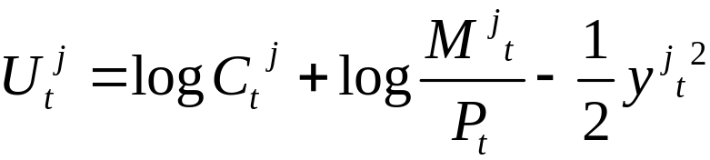

- Last term represents utility of leisure, disutility of labor supply. Are assuming production is just a function of labor y = square root of labor.

- Consumption: is a real CES index, an extension to more goods of the two-good index from before.
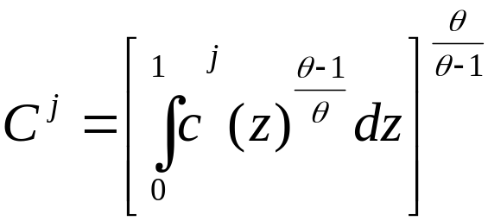

This implies a price index as an index over the goods consumer, just as we saw in lecture one in the case of traded and nontraded goods:
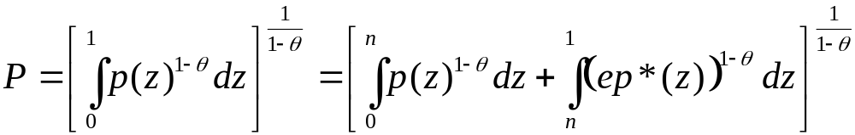
Where break up into home and foreign goods, assuming that law of one price holds for each one.

This comes from the same sort of exercise used before in this course for a Cobb-Douglas consumption index. What is the minimum cost of one unit of the consumption index.
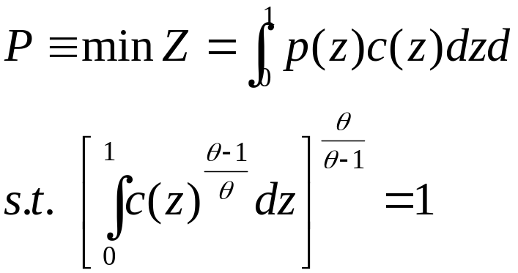
where Z is total nominal expenditure on consumption.

Note that we can do same for the foreign price index, P*:
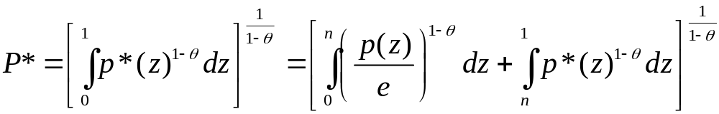

Note that as long as both countries have the same consumption index over goods, we will have PPP satisfied: P = e P*.
Budget constraint:
- Assume only asset traded is a riskless real bond (like models earlier) with real return r.

- Household budget constraint:

where P is aggregate price index, p(j) is price of the good this household produces and sells.

- Tau is tax with government, how it injects money into the economy:
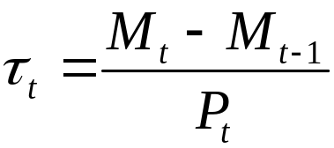
Demand curves:

- Consider the intratemporal choice between the various goods.

- Maximize index over consumption goods subject to budget constraint that total expenditure not exceed some limit gives an intratemporal allocation rule:
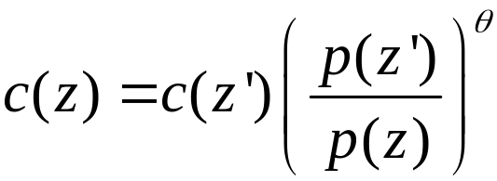
Integrate over goods:
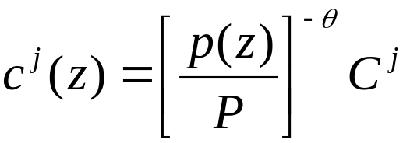

- This says that given the total consumption level, household will allocate it among the various goods depending on their relative price, relative to the overall price index.

- Take weighted sum of home and foreign households to get total world demand as share of total world consumption:
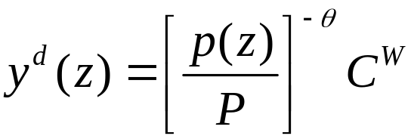
where 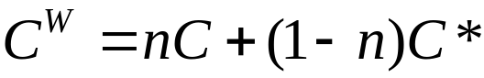

This is a demand curve, where the constant elasticity of demand is theta.
b) First order conditions:

- Now consider the full intertemporal problem:
choosing consumption, bond holdings, money demand, and either quantity of output (labor supply) or price -- subject to constraints: budget constraint, and demand they face for their product.

- If prices flexible: choose quantity of production,

- but if prices need to be fixed ahead of time, then choose price, let market determine demand and then we assume the agent must satisfy that demand when the time comes, supplying whatever labor supply is necessary.

Get first order conditions:

- Basic intertemporal consumption Euler: want to smooth consumption

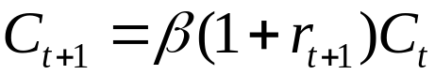

2) Money demand: agents must be indifferent between consuming a unit of consumption good on date t or using the same funds to raise cash balances, enjoying the transactions utility in period t and then converting the extra cash balances back to consumption in period t+1.

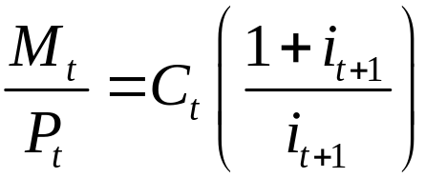 where i is nominal interest rate

3) Labor supply: marginal utility cost of producing extra unit of output (lost leisure) equals marginal utility from consumption of the added revenue that an extra unit of output brings.

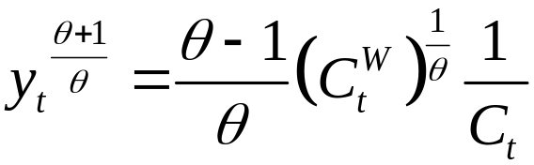

- Takes into consideration fact that if increase production, this will lower the price can sell good at, depending on size of market.

- Since we assume agents are price-setters rather than quantity setters, use the equation above along with the goods demand condition (demand as a function of goods price) to solve for the optimal price set for the good.

- Further, we assume that the agent must set this price one period ahead of time (price rigidity), so he sets price as a function of the expected value of the variables above.

Market-clearing conditions

- Money supply must equal money demand in each country. (implicit here because use M for supply and demand)

- Bond clearing condition: sum over home and foreign bond holdings equals 0.

- Can get a world goods market clearing condition, written in terms of consumption index, saying total world consumption equals total world production.
c) Solution:

Define equilibrium:
16 variables: C, y, M, b, P, tau, price of representative good p(h) and foreign counterparts for these, as well as the exchange rate and interest rate.

16 equilibrium conditions:
- FOCs for consumption, money demand, labor supply (price setting) with foreign counterparts (6)
- Household budget constraints (2)
- Government budget constraints (2)
- Definition of price indexes (2) (involves nominal exchange rate)
- Demand curves for representative national good (2)
- Goods market clearing condition (in terms of consumption index) (1)
- Bond market clearing (1)

Can’t get full analytical solution, but can get some equilibrium relationships that help with intuition.

Solution strategy:
1) find a steady state, as a function of relative wealths.
2) Linearize equilibrium conditions around steady state.
3) Find the differences between national variables
4) Find world aggregates. Put this together with national differences to conclude regarding individual national variables.
d) Initial Steady state:

- Derive consumption functions in steady state, using consumption Euler and intertemporal budget constraint):
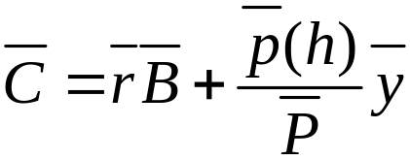

- If want a closed form solution, consider a case of complete symmetry where the net foreign asset position is zero (Bbar = 0) In this case we have:

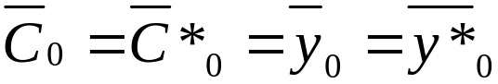 in the initial steady state.

Note that with monopolists, the level of production in steady state will be too low. Because they know that if increase production, this will lower the price. So they restrict production below efficient level.

- Plug these into the labor supply decision:
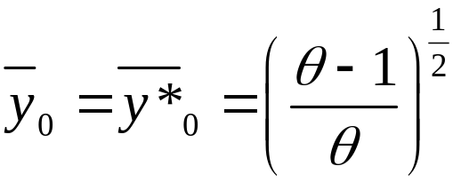
- Notice first that money does not matter for the steady state.

- Notice next that this level of output is less than what a social planner would choose, based on the real part of the agent’s utility function:
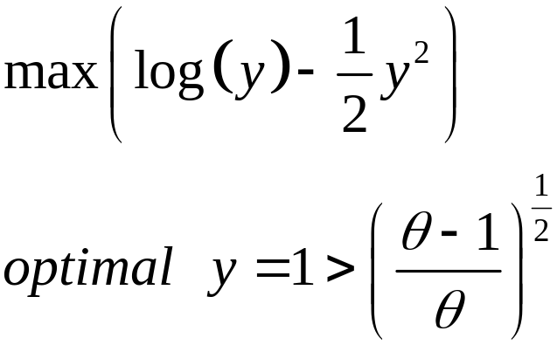
This is important to the welfare conclusions later.

- Next log linearize all equations around the symmetric steady state. I skip most steps.

- Use lower case letters to represent percent deviations from initial steady state.

e) Short run effects - permanent rise in money.

MM-curve
- Combine (as differences across countries) the consumption Eulers and money demands, and PPP:
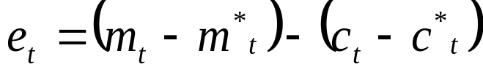

- This says: if we increase home money supply, this will increase money supply relative to money demand, and this causes the exchange rate to depreciate.

- Graph it as e versus relative consumption: downsloping to show a rise in consumption raises money demand and causes e to appreciate. A rise in m would shift curve to right: e depreciates for a given relative consumption.

GG curve
- Combine the linearized versions of the goods demand equations (where prices are fixed), along with the linearized versions of the labor supply conditions (to change outputs into consumption levels, you get:

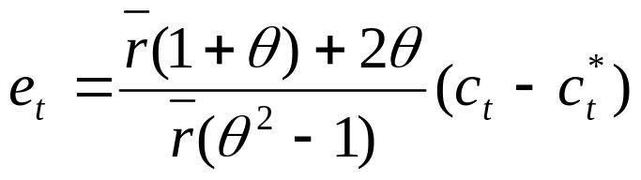

- Graphs this as an upsloping curve because it says an e depreciation will shift demand toward home goods because prices fixed and are cheaper relative to foreign, production increases, so income increases, so consumption rises

M2
G
e
M1

c-c*

M2
G

M1

- A rise in home money supply shifts the MM curve right. This has the effects:
1) e rises (home currency depreciation)
2) (c-c*) rises: a rise in home consumption relative to foreign.

- It is also possible to write these in terms of output differences, given that the two national demand conditions when linearized imply that (y-y*) = e.

- So we also conclude that:
3) (y-y*) rises: a rise in home relative to foreign output.

Now Find world aggregates:

- Doing more manipulations not shown here, we find that:
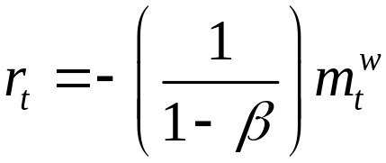
So if either country increases its money supply, this will make the common world real interest rate fall.

- And find that:
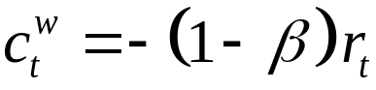
So a fall in the interest rate will raise world consumption.
In fact:
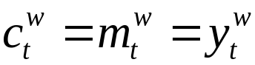
- Summarizing: 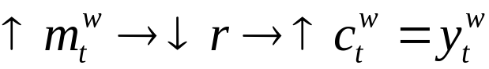
- This shows that this is not a zero sum game.

- Before the monetary shock, output was sub-optimally low, held down by the monopolists to maximize their profits.

- But a surprise rise in money supply lowers the real interest rate and raises demand; the monopolists must accommodate this demand by increasing production.

- Put the information together to conclude about individual country variables.

- Know (c-c*) rises and (c+c*) rises, so know c rises home. Regarding the foreign variable, we can’t tell from here what happens to c*, but can use other equations to show it rises as well.

- Know (y-y*) rises and (y+y*) rises, so know y rises at home. Regarding the foreign variable, we can’t tell what happens to y*, and the effect is in general ambiguous.

- This ambiguity in foreign output comes about because there are two effects:

1) The rise in money lowers the real interest rate, which would tend to raise foreign demand and hence output.

2) but it also makes the nominal exchange rate rise, so foreign goods are more expensive. This shifts demand toward home goods and away from foreign goods, and this fall in demand would lower foreign production.

- As long as the elasticity of intratemporal substitution (theta) is greater than the intertemporal elasticity (which is unity because of the log utility specification), the change in the relative price will dominate the effect of the change in interest rate.

- Note that this would be an example of the “beggar thy neighbor” policy emphasized in the Mundell-Fleming model: a home monetary expansion raises home output at the expense of lowering output abroad.

f) Welfare effects:

- But we should not judge the impact of the policy in terms of output levels, but instead in terms of agent welfare, using the utility function on which the model was based.

- If substitute equilibrium variables into utility function, most of terms cancel out and you get:
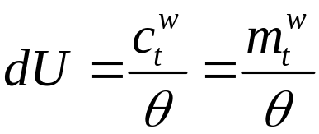

Interpret:

- Welfare rises the same in both countries regardless of who undertakes the monetary expansion, because consumption rises in both countries.

- This is a first-order effect. The monetary expansion forces a rise in the world level of production and overall consumption above the monopolistic level.

- This shows the importance of using optimizing models rather than ISLM/ Mundell-Fleming models. In the latter you can’t do welfare analysis.

g) DSGE Implementation (Kollman JIE 2001):
- See if OR-type model can generate stylized facts saw in data. Augments model for data comparison.

Model Description (how different from OR)
- Has uncertainty.
- Small open economy rather than two-country.
- Consider sticky prices and wages also
- Consider stickiness of varying durations: 2 quarter, 4 quarter, and gradual adjustment.
- Multiple shocks: money supply, labor productivity, price level in rest of world, and world interest rate.
- Nominal bonds, in either domestic currency with rate r or foreign currency at r*.
- More general utility function and production function

Sticky-Price specification:

Version one: price set k=periods ahead of time. So at period t choose Pt+k that expect to satisfy optimality conditions, based on info available at period t.

Version 2: Calvo adjustment mechanism:
- Firms only allowed to change price if receive a random price-change signal with probability (1-delta).
- So each period fraction (1-delta) of firms change their price and fraction delta will not.
- Firms solve for the optimal price given this expectation.
- Under certain conditions the prices can be aggregated to imply the aggregate price is a weighted average of prev-ious period’s aggregate price and the optimal reset price.
- This has the convenient implication that the aggregate price will gradually adjust to a shock.

Impulse responses:

- Figure 1: four-period fixed price and wage. Monetary shock lowers domestic nominal interest rate, and raises domestic output, nominal and real depreciation of country’s currency.

- Figure 5: Calvo adjustment: same, but smoother, more gradual adjustment.

- Note: overshooting
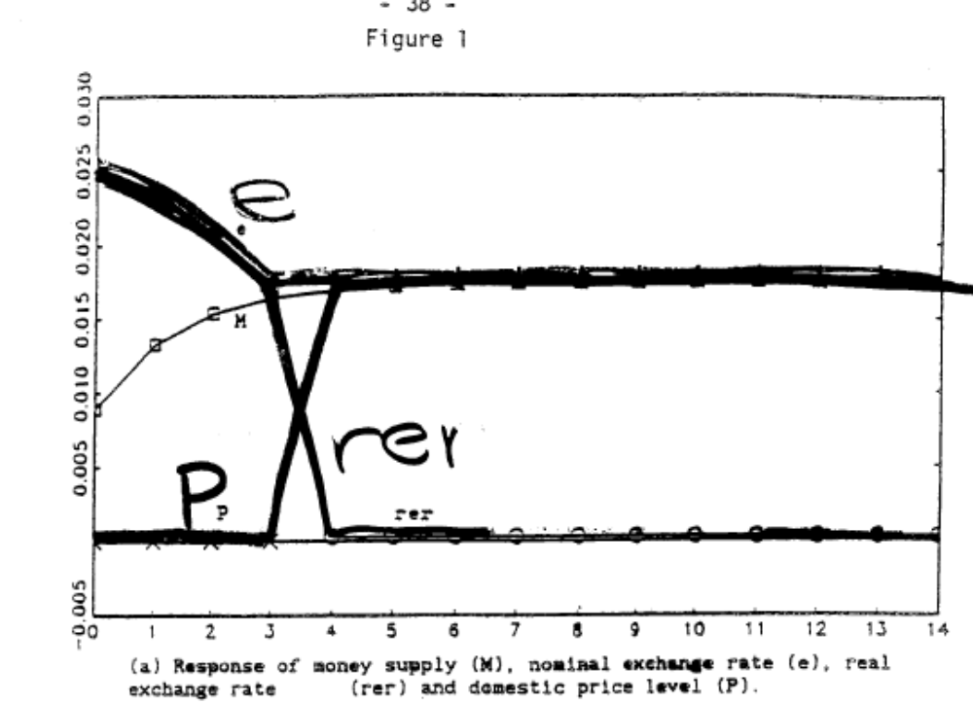
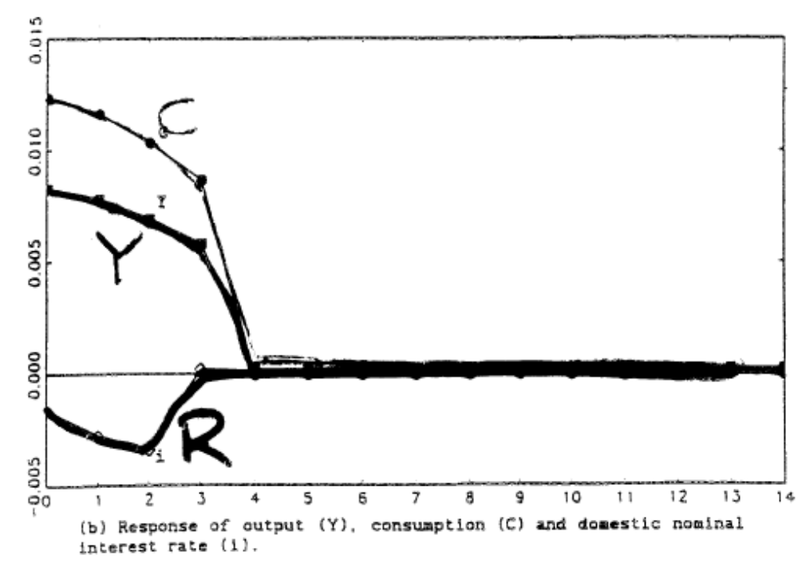
Moments from simulation

Recall exchange rate facts to match:

- real and nominal exchange rates move together,

- volatility 4X that of output

- persistent (with serial corr of about 0.8).

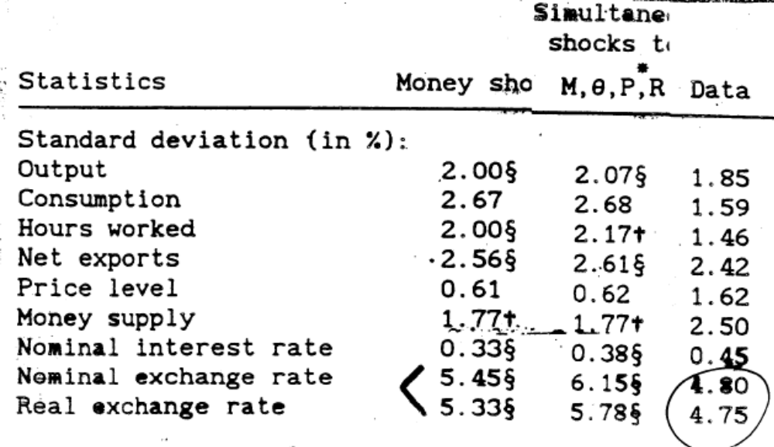
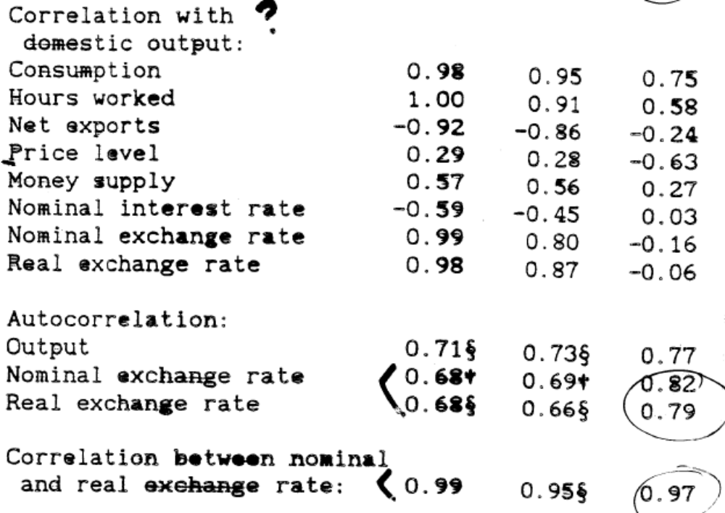
4-period stickiness:
- corr(e,rer) = 0.81 compared to 0.97 in data.
- Vol(e) = 3.64 compared to 4.75 in data
- Autocorr(rer) = 0.64 compared to about 0.8 on average

Calvo stickiness:
- Calibrate with 8% of firms adjust each quarter.
- Suspiciously high degree of stickiness – means that on average price reset only every 3 years
- corr(e,rer) = 0.99 compared to 0.97 in data.
- Vol(e) = 5.45 compared to 4.75 in data
- Autocorr(rer) = 0.68 compared to about 0.8 on average

Questions for Discussion

1) What role does PPP and the law of one price play in the Obstfeld-Rogoff model?

2) List 3 specific ways in which this model differs from the Mundell-Fleming model you have studied previously?

3) Might these differences lead to different implications for policy analysis?

4) Compare the usefulness of this model for monetary versus fiscal policy analysis.

Part 2) Sticky Price Models and Exchange Rate Puzzles

1) Chari, Kehoe and McGrattan (RES 2002)

- The model is similar to Kollmann (2001 JIE), in that it is an RBC model augmented with money and sticky prices.

- It is different in that it assumes prices are set in stag-gered overlapping Taylor contracts (Taylor 1980, JPE).
Core of the model is a standard RBC model.

- Two countries: home and foreign

- Each country produces a continuum of intermediate goods indexed by i over [0…1].

- Producers are monopolistically competitive, with market power. Can choose different prices in the two countries.

- These intermediate goods are combined to make final goods, specific to each country, used for consumption, investment and government consumption.

Aggregator:
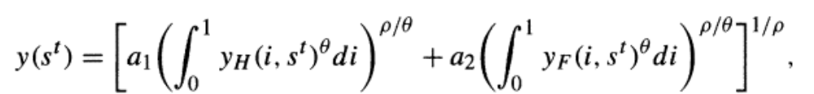

- Production of intermediate uses capital (k) and labor (l):

- Capital accumulation subject to adjustment costs (x is investment)

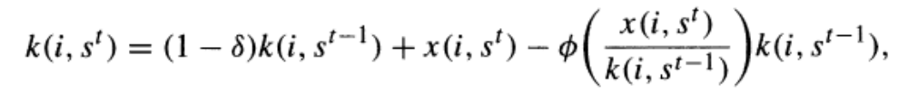

- Complete asset markets: complete set of nominal state-contingent bonds, where
  - s^{t} is history of events up to period t.
  - B is holding of state-contingent bond
  - Q(s^{t}) is price of one unit of home currency in state s^{t}.
  - Q(s^{t+1},s^{t}) = Q(s^{t+1})/Q(s^{t}) is price of bond bought in s^{t} and that pays off in s^{t+1},
- Price setting:

- Index home firms i ∈ (0,1) and divide into N groups.

- In period t fraction 1/N of the home firms, i ∈ (0,1/N), set their price p(i) for N periods.

- Next period, firms indexed i ∈ (1/N, 2/N) set their prices, and so on.

- The logic is that when a firm has the opportunity to reset its price, it will do so only partly, because it knows some of its competitors have not reset their prices yet.

- Calibration will imply contracts last one year.
Price setting problem:
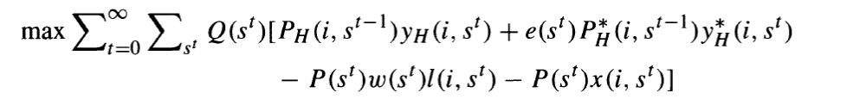
and optimality conditions:
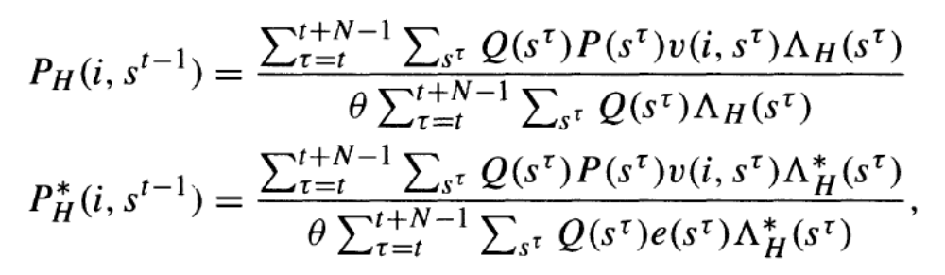
Where: 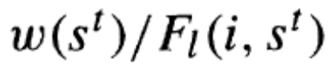
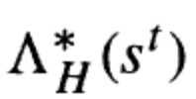 = 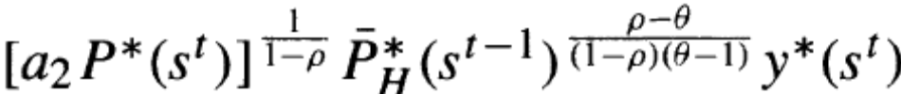

We will consider a simpler problem to aid interpretation…
Aside: Simple version price-setting problem:

To deepen understanding, consider a simpler version of price setting problem: (single-period predetermined price, abstract from investment and state notation)

Suppose monopolistically competitive firm i faces demands:
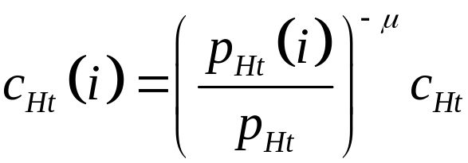 at home and
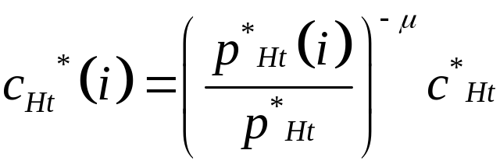 abroad,
where firms takes overall demand 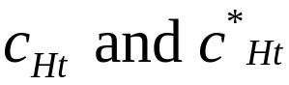 as given.

And production function: 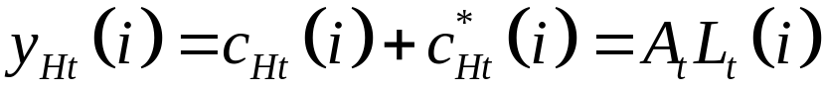
Where labor is paid at wage rate W_{t.}
Maximization problem:

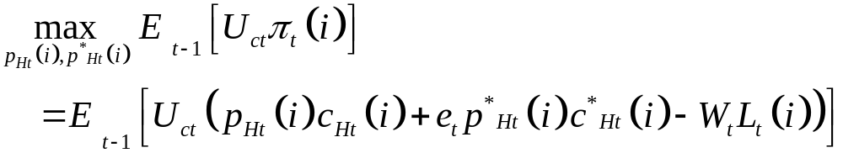
where profits over various periods and states are valued using marginal utility of households, U_{ct}.

Substitute in production and then demand functions:
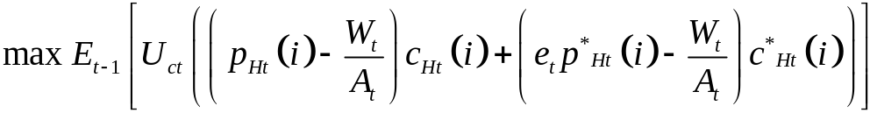
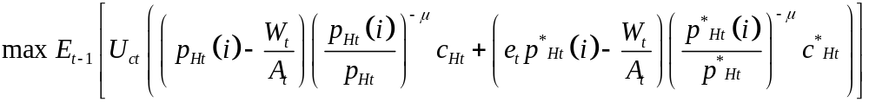
FOC for foreign price, 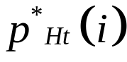:
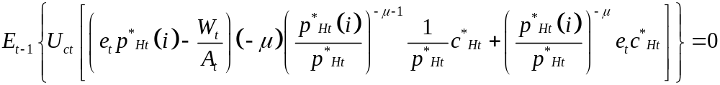

Impose symmetry (and the unit interval of goods): 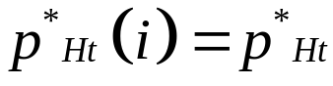
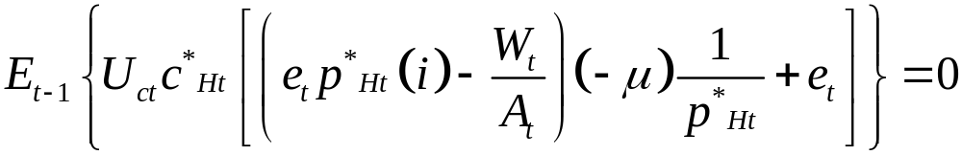
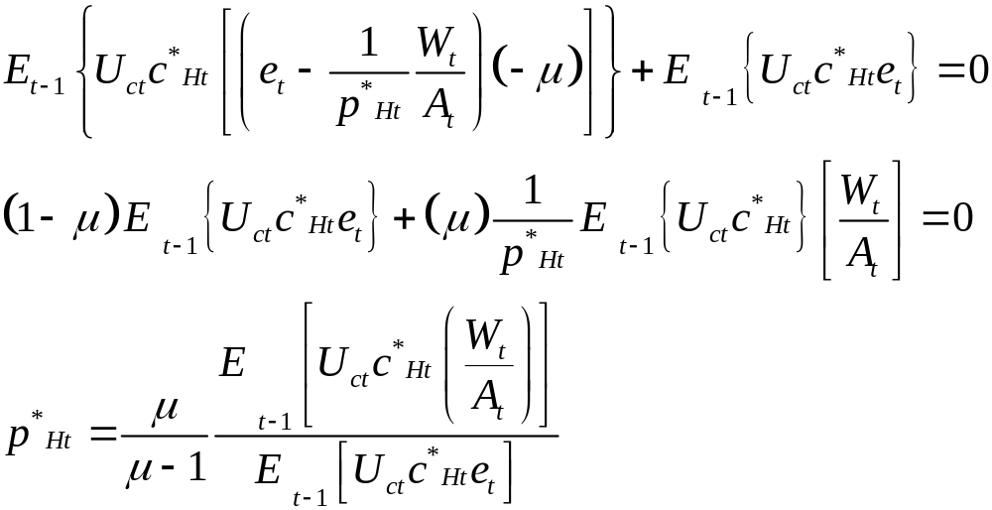

Interpret: price as a markup over marginal cost, augmented by expectations about demand, marginal utility, and exchange rate.
If take a linear approximation of this condition around a deterministic steady state, as done in RBC literature:

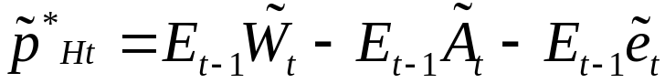

The repeated terms drop out, and it becomes simpler.

Note: To represent this conditional in a stochastic linear system, need to define expectation terms, which will involve a non-invertible matrix. This rules out solving the system by the method of Blanchard-Kahn. Need an alternative not requiring matrix inversion, such as QZ decomposition.
Back to interpreting price setting conditions from paper:
Q: like the marginal utility used for discounting above

P v: nominal marginal costs, like W/A above

:uncertain demand.

Sum over states: expected value

Sum over periods: price is average over optimal price for each of period during the contract.
Households:

- Infinitely lived, choosing consumption, labor, and money demand, to maximize discounted sum of utilities U, subject to budget constraint:
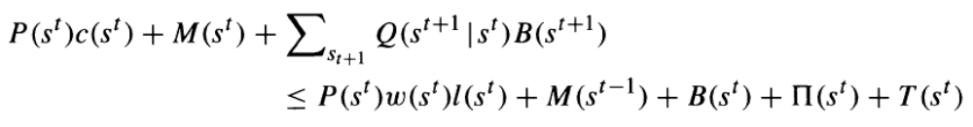

- Preferences: separable in consumption and leisure:
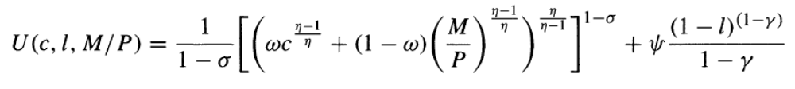
- Usual first order conditions for labor supply, money demand, and risk sharing:

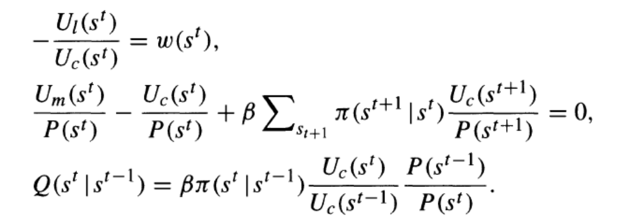

- Note that iterating on the risk sharing condition implies the following relationship between the real exchange rate (q) and marginal utilities:
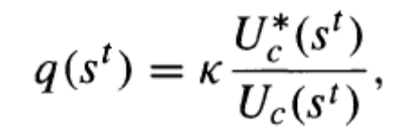 (A)

- Government: assume a constant money growth process, injected by transfers:

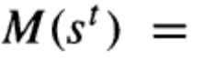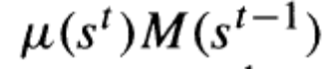

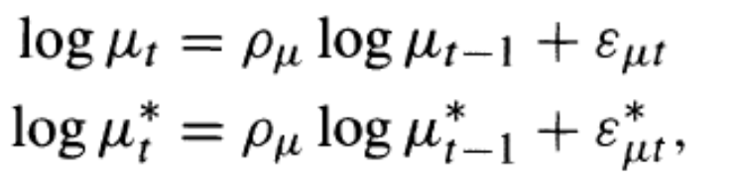

With money distributed by transfers

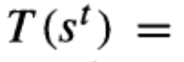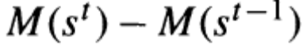

Calibrate one country to U.S., other to European aggregate.
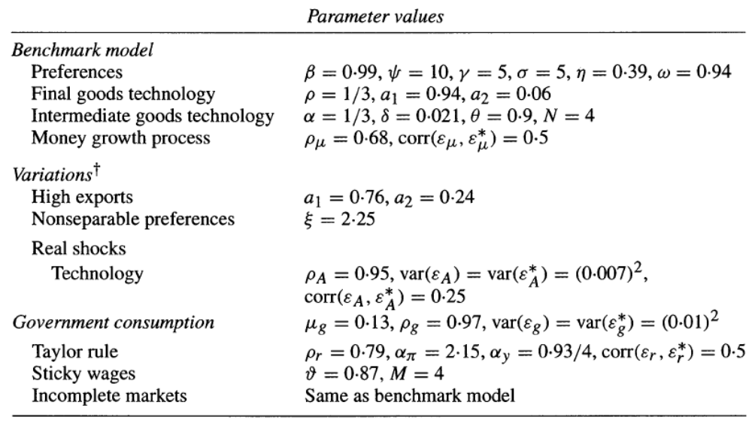
Findings:

- Run stochastic simulations, under shocks to monetary aggregate. HP filter, and report moments of simulated data.

- Benchmark case: good on volatility, not so good on persistence. (See table 5 below.)

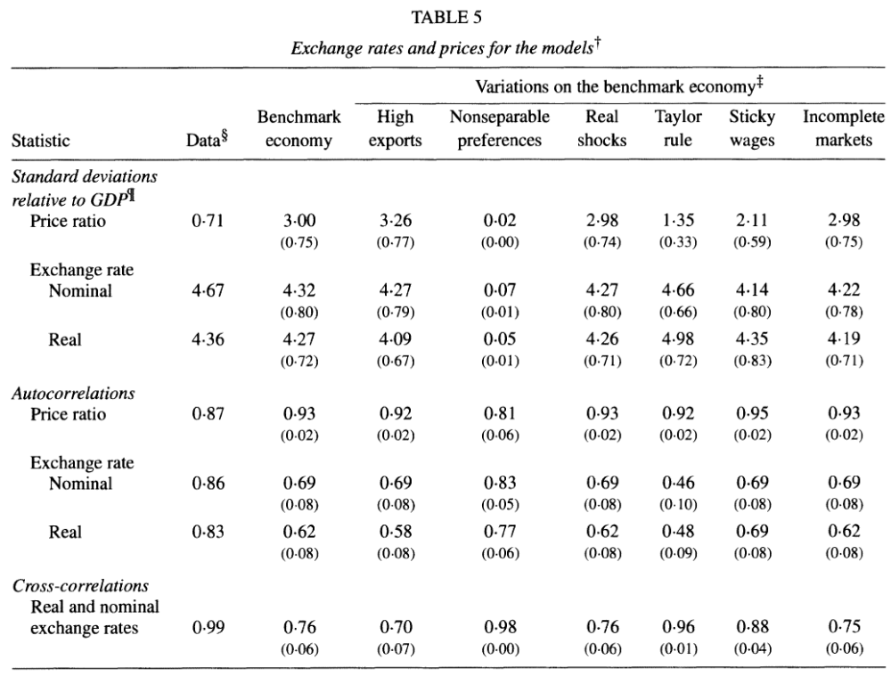
Intuition for volatility: equation (A) above implies:
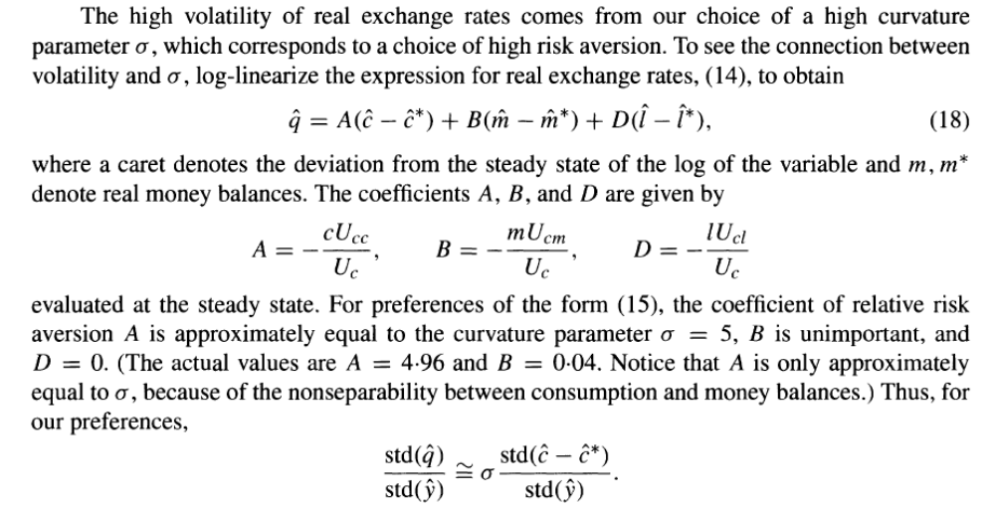

Lesson: With sticky price models of this type you generally can generate as much real exchange rate volatility as you want, by adjusting the risk aversion parameter.
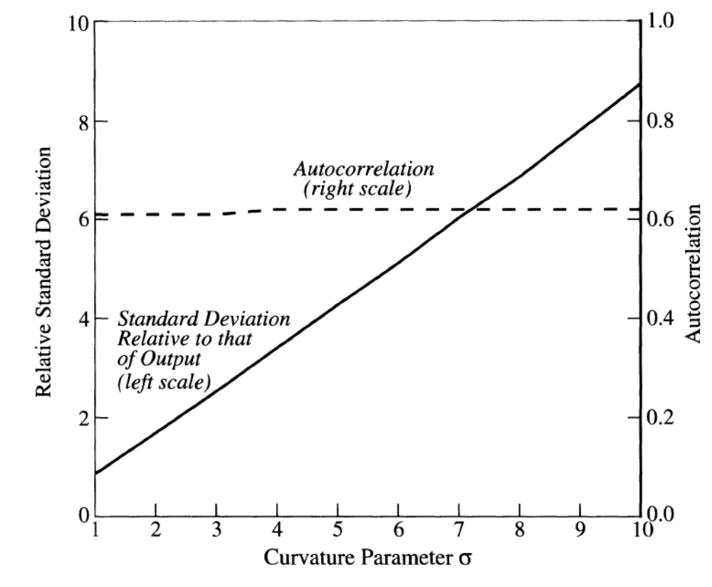
Lesson: But this trick does not help generate persistence.
- Table further shows that many model extensions have little
effect (incomplete asset markets, sticky wages).

- Note that if the preferences are specified as non-separable, this can raise persistence. But this comes at the cost of losing all volatility.

- With nonseparable utility, the risk sharing condition is affected also by leisure, not just sigma and consumption, so the mechanism above is no longer at work.
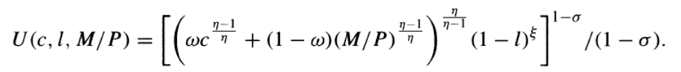

- An additional problem with main result above: it implies a high correlation between consumption and real exchange rate (also called the ‘Backus-Smith puzzle’: JIE 1993)

- The model implies a perfect correlation, as seen from the risk sharing condition above:

- But in the data the correlation is varied and negative on average.

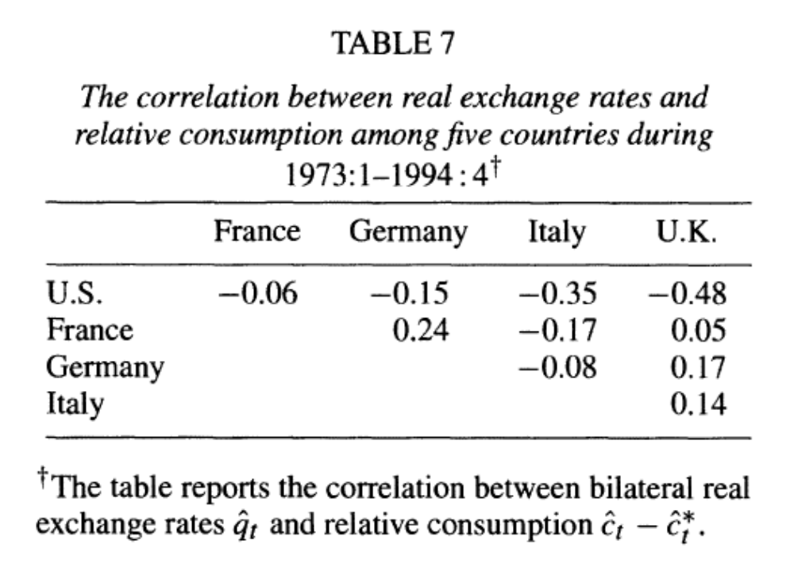

- Neither incomplete asset markets nor habits in prefer-ences can break the counterfactual high correlation.

2) Johri and Lahiri (2008 JIE)

Questions for class discussion:
1) What two new features does this paper add to the model of Chari et al.?
2) Have we seen one of these before? How different?
3) Why should these two model features help explain real exchange rate persistence?
4) How is home bias important to this result?
5) How is the intertemporal elasticity important here?
6) Do you think this model can explain the Backus-Smith puzzle also?
This paper augments the model of Chari, et al. with two features to generate more persistence in the real exchange rate:

- Learning by doing in production: Higher production today leads to accumulation of organizational capital by a firm, which lowers cost of production in future.

- Habits in leisure preferences: change in leisure today affects marginal utility of leisure tomorrow

Model: just like Chari et al in most respects:

- Two countries

- Monopolistically competitive intermediate producers, selling to both countries

- Production using labor and capital

- Capital accumulation subject to adjustment costs

- Complete asset markets among households

- Price stickiness (but only one period stickiness)

Habits

- Specify preferences:
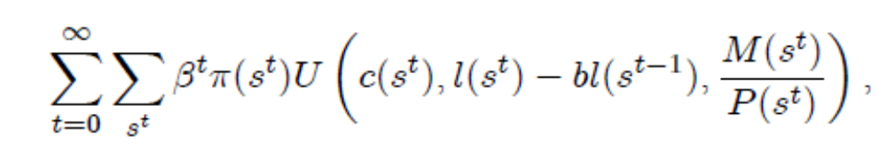
Where b>0 indicates habits.

- The labor supply first order condition becomes:
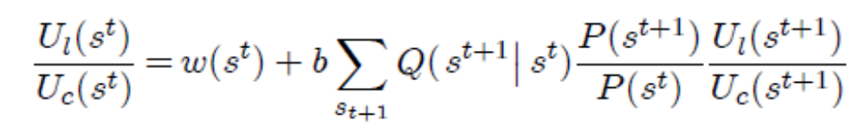
Where habits enter in the second term on the right side.

- So an extra unit of leisure raises the stock of habits tomorrow.

- This helps generate persistence by spreading out over time the rise in labor supply and output after a monetary shock.
Specific utility function used here:

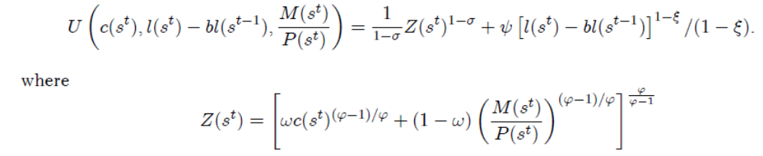

Like Chari, preferences are additively separable in consumption and leisure.
Production:

Production function:
where H represents organizational capital, which depends on output yesterday.
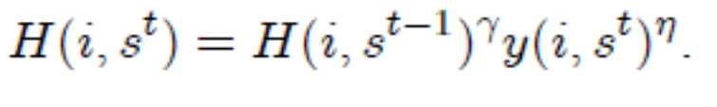
Firm chooses price and organizational capital for the next period to maximize profit:

Where C is nominal cost:
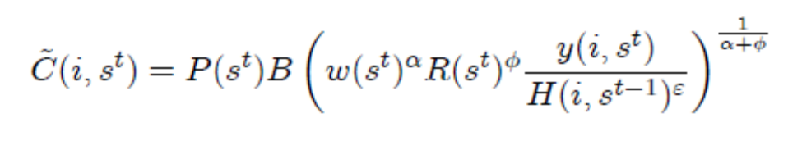
First order conditions for prices and H:
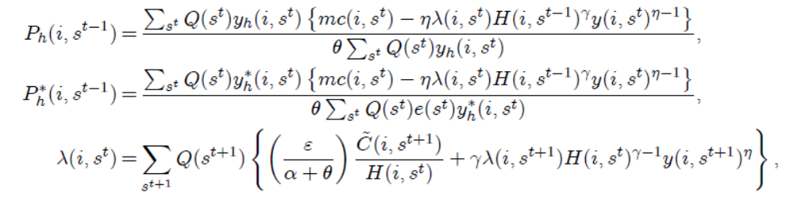

Price setting: term in {} shows that firms take into consider-ation that pricing today affects organizational capital tomorrow through effect on demand and hence output.

Last equation shows that the value of an additional unit of organizational capital reflects both its implied cost savings tomorrow as well as its positive effect on the future stock of organizational capital.

Why useful for persistence:

- When demand is high after a monetary shock, the firm will choose not to raise price fully, so that it can gain the organizational capital.

- This reduces costs in subsequent periods and further lowers the desire of firms to raise prices in subsequent periods.

Calibration:

High risk aversion: sigma = 11 (needed to make Chari trick work here for exchange rate volatility)

High home bias in preferences: a1 = 0.94.

Habit parameter from outside studies: b= 0.8.

Three parameters governing learning taken from small number of outside studies on this. Implies that doubling level of output reduces future production costs by 30%.
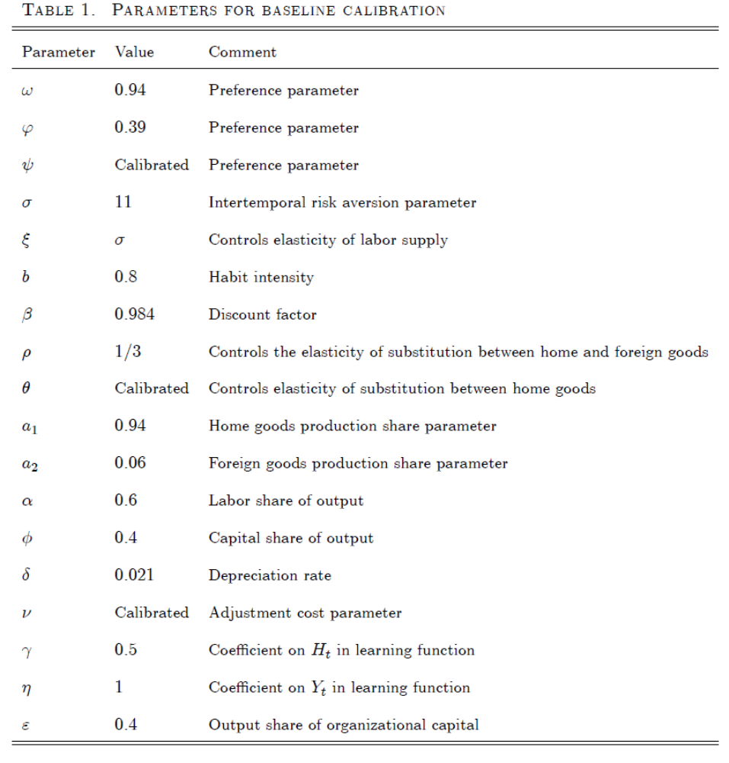
Results

Solve linearized model and simulate under same monetary shocks as Chari et al.

- Model without LBD or habits (‘benchmark’) has zero persistence in the real exchange rate.

- The combination of LBD and habits delivers a serial correlation of the real exchange rate of 0.80, which is pretty close to the value of 0.94 in their data.

- Both features are needed to generate enough persistence; either alone only gives serial correlation around 0.45.

- Home bias in preferences necessary for persistence.

- Volatility is OK for all cases considered, given sigma.

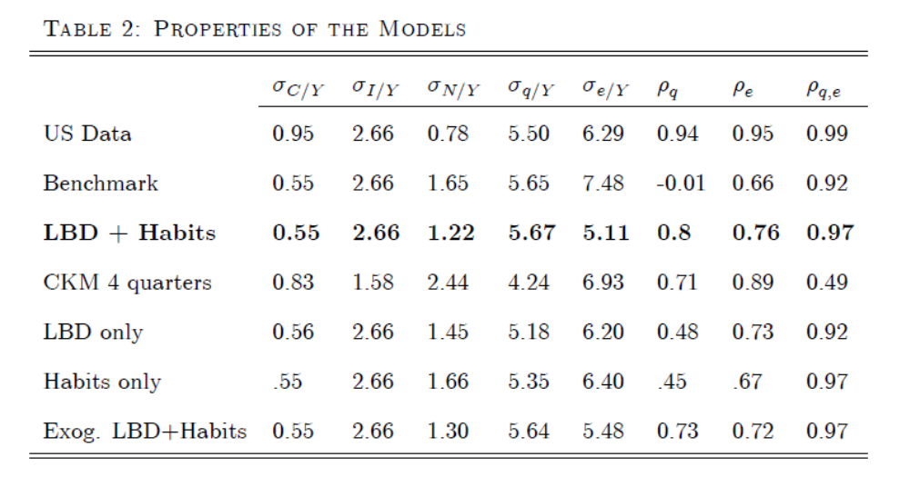
Note: high degree of persistence in LBD + Habits case.

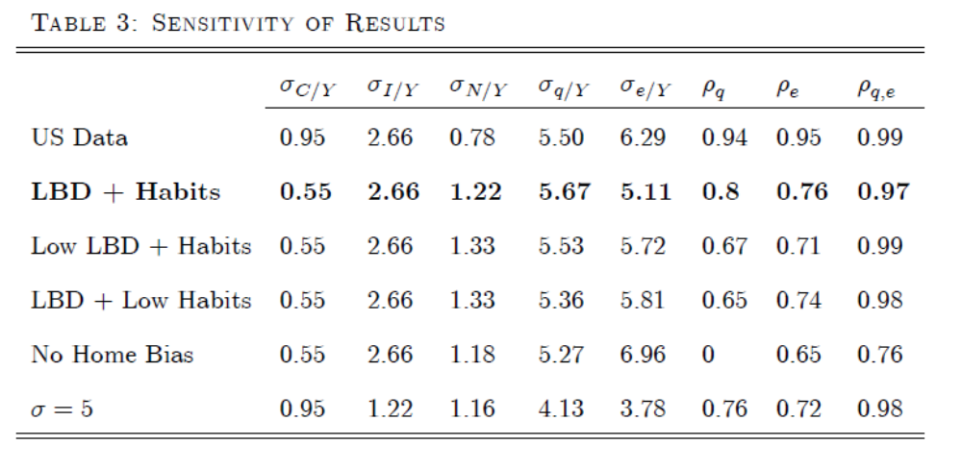

Note: low persistence of case with no home bias.

Questions for Discussion:

- Do you think their model can explain the “Backus-Smith” puzzle?

- JL claim volatility is not a problem, because you can always raise the risk aversion parameter to get any volatility you want. Do you agree? Is there a limitation?

- Why does the case of no home bias in preferences in JL generate no real exchange rate persistence, despite the presence of learning by doing and habits?

