Topic 8: Financial Frictions and Shocks

Part1: Asset holding developments

- The relaxation of capital account restrictions in many countries over the last two decades has produced dramatic increases in international asset flows,

- with a temporary slowdown during financial crisis.

- The accumulation of large foreign asset positions have implications for theories studied earlier in this course.

- Integrated financial markets provides channel of international transmission of financial shocks, as in Global Financial Crisis of 2007-9.
a) Observations (Lane and Milesi Ferretti papers)

- The sum of assets plus liabilities has grown much, especially in the late 1990s.

- Financial integration has grown faster than goods trade integration.

- Gross holdings (assets plus liabilities) has grown much more than net holdings (assets minus liabilities).

- Returns on US assets abroad have tended to be higher than US liabilities. This explains why US net interest income was positive until recently, even though it has been a net debtor since 1989.
Chinn-Ito index of caitgal account openness ranges -2.5 to 2.5
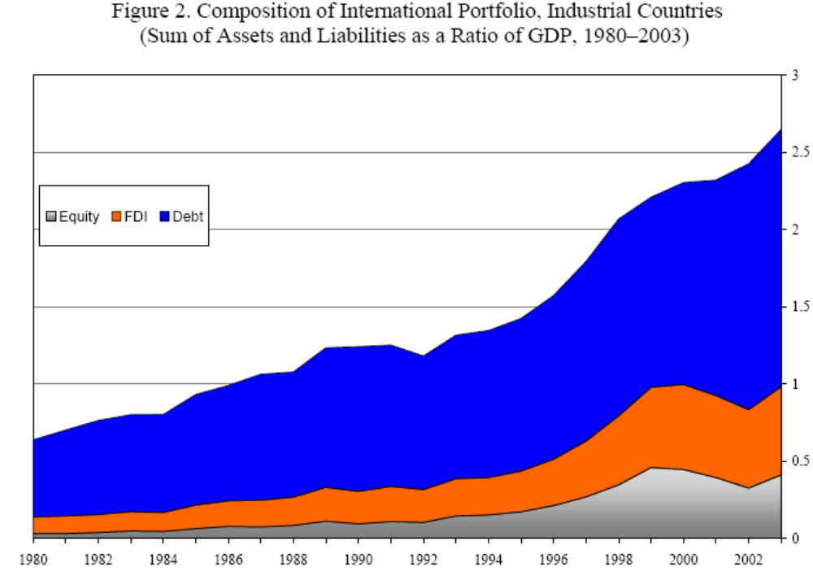
source: Benertrix, Lane, Shambaugh (2015)
b) the US portfolio is special:

- While US gross assets are primarily in foreign currency, its liabilities are largely in US dollars.

- While the US is a net creditor in foreign currency assets (50% of US GDP in 2004) it is net debtor in dollar assets (72% of GDP). Overall, net debt position of 22% of GDP.

- This implies that a change in the nominal exchange rate affects the value of the net asset position: a 10% depreciation of dollar transfers 5% of US GDP.

- Implications of this fact will be developed in a theoretical model in the third section of this lecture.

Part2: Financial Adjustment: Gourinchas and Rey (2007)

- This paper studies how capital gains on gross external assets provide an alternative channel for international BOP adjustment to the familiar channel via trade flows.

- We have seen in our intertemporal models that a country running a current account deficit to smooth over a shock needs to finance this by trade surpluses in future periods.

- An alternative way of satisfying the budget constraint would be for the valuation of foreign holdings of home assets to drop.

- A likely way that this would occur would be through exchange rate depreciation.

a) Theory

- The theory is analogous to that used for the Present Value tests of Campbell, used to test the intertemporal approach to the current account used in this course.

- The authors refer to their approach as an “intertemporal approach to the Financial account.”

- Begin with a rewriting of the BOP (budget) constraint:

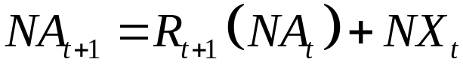
Where
- NA is defined as the difference between gross foreign assets (A) and gross foreign liabilities (L).
- NX is net exports, exports (X) minus imports (M).
- R is total return on net foreign asset portfolio.

- As in the earlier present value tests, linearize this budget constraint:

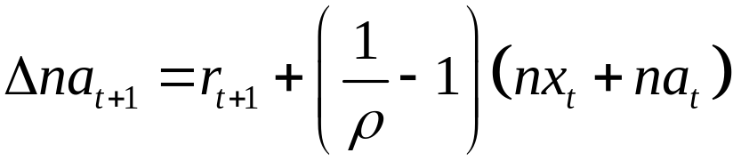
Where 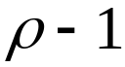 is the steady state ratio of net exports to net assets (NX /NA).

- The total rate of return on the net foreign asset portfolio can be approximated as a weighted combination of the rates of return on the countries external assets and that on the country’s external liabilities (which can differ)

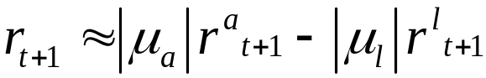

- For reference later, define a linear combination of net exports and net assets:

Which can be interpreted as the deviation from trend of the ratio of net exports to net foreign assets (NX /NA).

- The intertemporal budget constraint implies a condition analogous to the test condition from the present value CA literature:
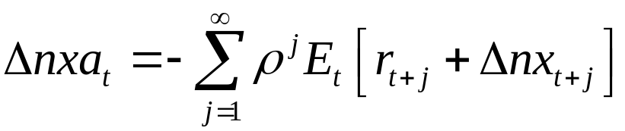
(key PV condition)

- This shows that movements in the trade balance and the net foreign asset position must forecast either future portfolio returns, or future net exports growth, or both.

- So there are two channels of adjustment to a net export imbalance: the usual trade channel, and an asset valuation channel.

- Note that the latter, represented in r, can take place by changes in the nominal exchange rate, if the gross asset positions for assets and liabilities tend to be denominated in different currencies.

b) Empirical Implementation and Results

Data: The authors must work quite hard to collect the data needed to compute the series for total returns, r, as this requires estimates on weights for different categories of assets and their returns.

Present value test:
- The authors follow Campbell methodology in testing the PV condition above.

- They use a VAR to generate forecasts for the expected discounted sums of r and NX above.

- They then can use the equation above to compute a model-consistent forecast of 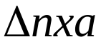, which then can compare to the data using a Wald test.

- They find a chi-squared statistic of 0.325, and with three restrictions, the p-value is 0.955. So they cannot reject the restriction of the Present value condition above.

Decomposition:
The authors decompose into the two channels implied by the PV condition:
- the trade channel (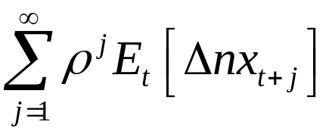)
-and the valuation channel (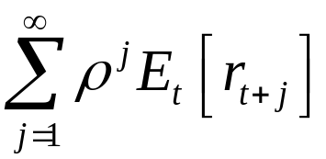).

- The valuation channel plays an important role, accounting for 31% of overall external adjustment.

- They conclude that the valuation channel does not replace the need for the US to generate net exports in the future, but it does significantly reduce the magnitude of adjustment needed along the trade channel.
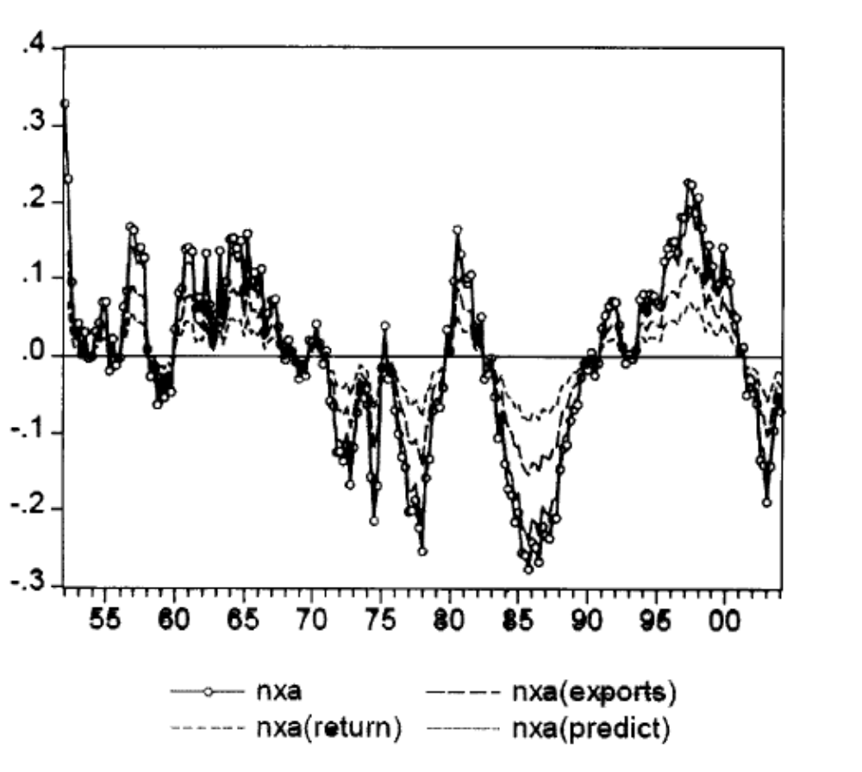

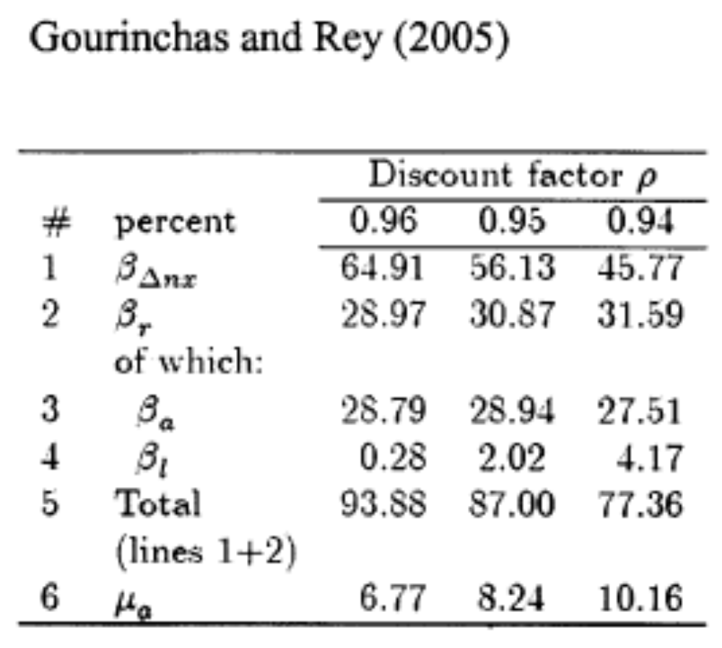

Part 3: Implications for monetary policy models: Tille (2008)

a) Model:

- Two country model sticky price model like OR (1995), but with new asset market features.

- Can hold home and foreign bonds and equities. Nominal bonds in H and F currency (one period and perpetuity bonds that pay a fixed nominal interest rate for all future periods).

- Equities share in firm in H and F, which are mutual fund claim to other countries nominal profits.
- assume steady state with zero net foreign asset position, so can get closed form solution.

- Nonetheless, there are nonzero gross holdings in each currency.

- Calibration: representative of US case. Foreign currency -assets represent 50% of home GDP (either bonds, equities, or combination of the two).

Four cases for asset market in each table:
1) no international asset positions
2) bonds only economy
3) equities only
4) mixture of bonds and equities matching US case.

b) Findings (sticky price version of model)

With no financial integration (column 1), get something close to the basic Obstfeld-Rogoff (1995) story: Increase money supply raises production and consumption.

Bonds only economy: (Column 2)

- We see evidence of a wealth transfer.

- May appear that the asset valuation effect has little impact on consumption

- But note the fall in home long-run output.

- It is also very clear in the effect on home welfare, which rises 5.8 times larger than in the no asset case.

Part 4: International transmission of financial shocks and Global Financial Crisis

- International comovement was particularly strong during recent financial crisis.

- But was temporary, associated with particular financial shock.

- Countries with greater financial linkages to US tended to experience US Great Recession more strongly.

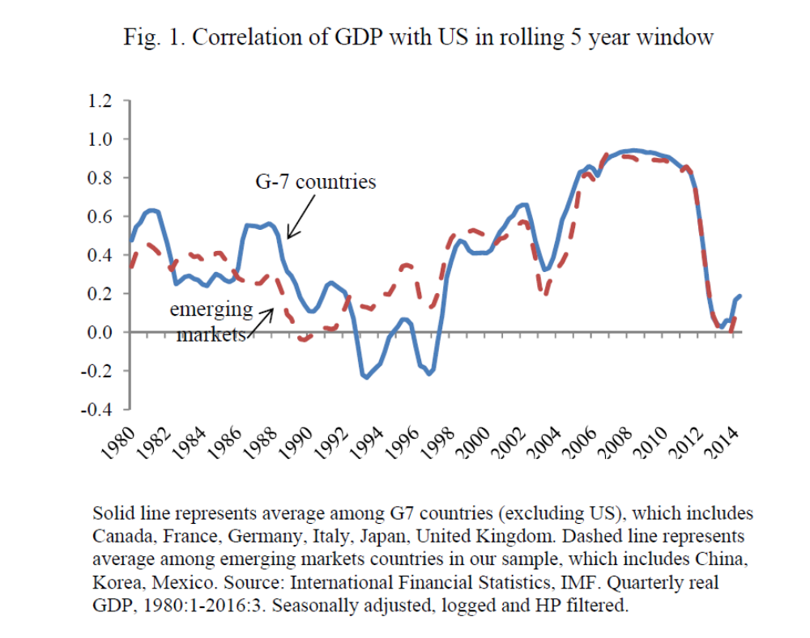
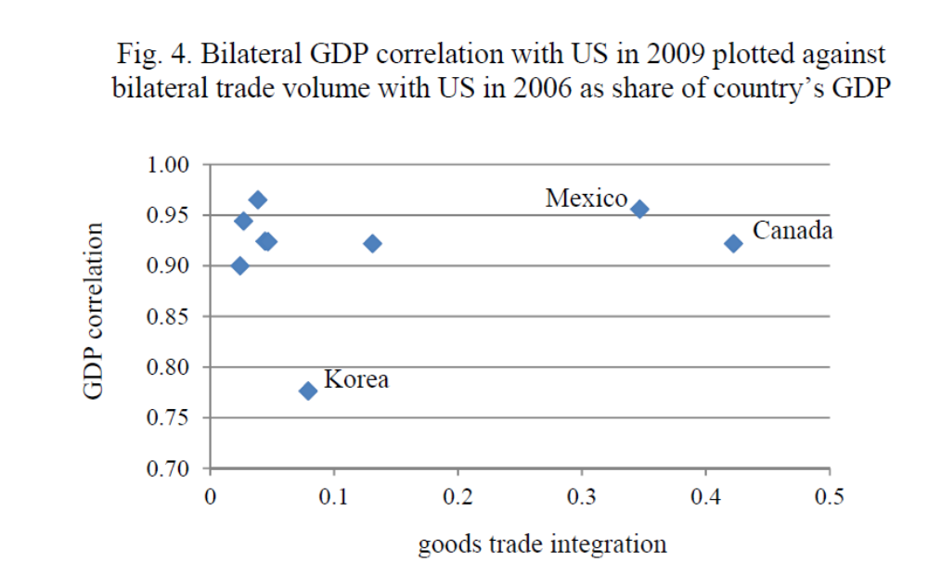

a) International Recession (Perri and Quadrini, 2016)
(slides from Angsoka Y. Paundralingga)

GDP during past recessions:
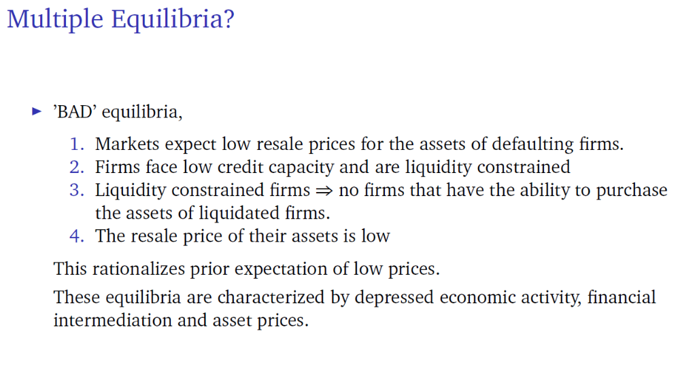
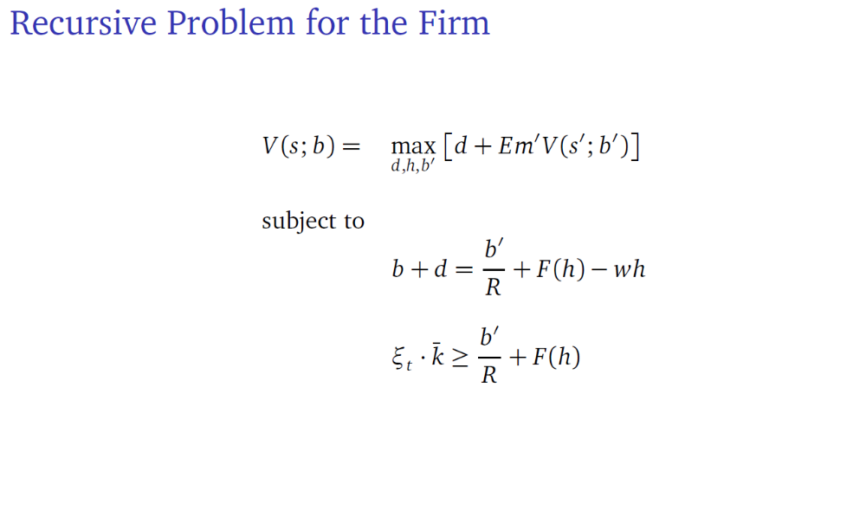
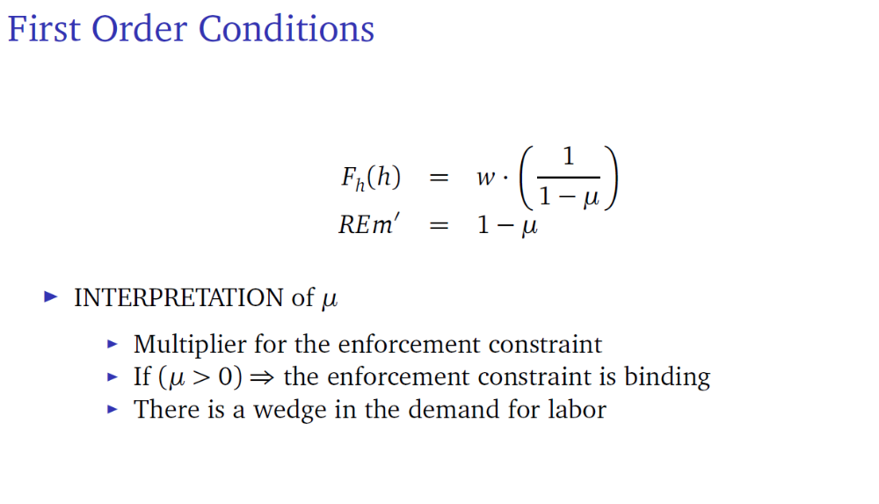
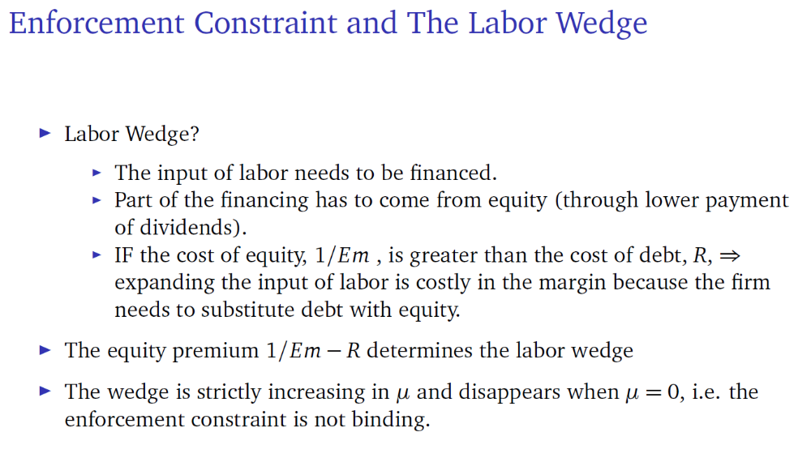

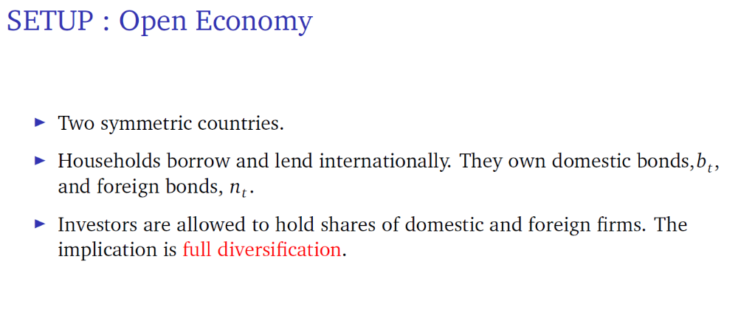
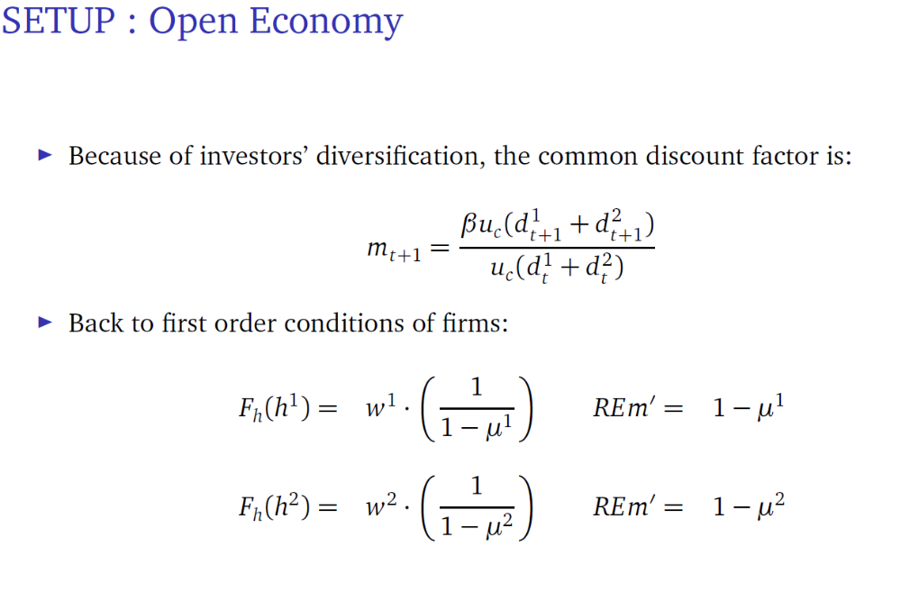
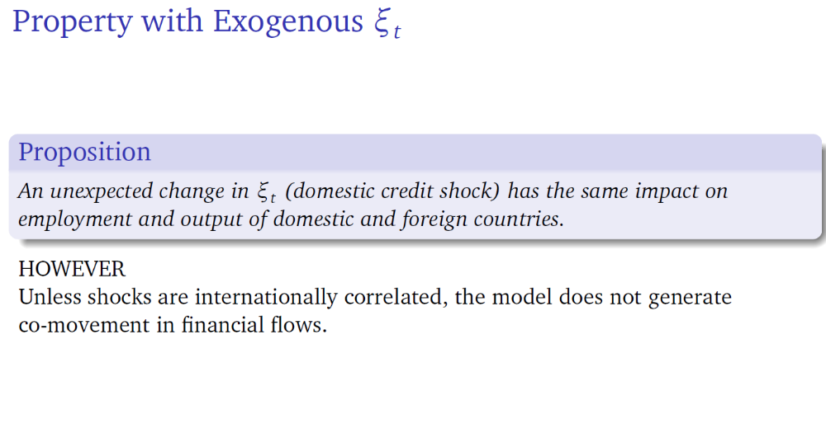
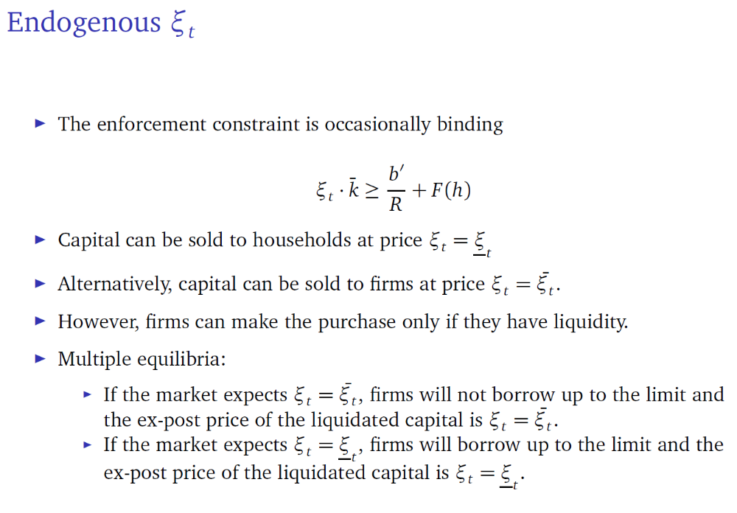
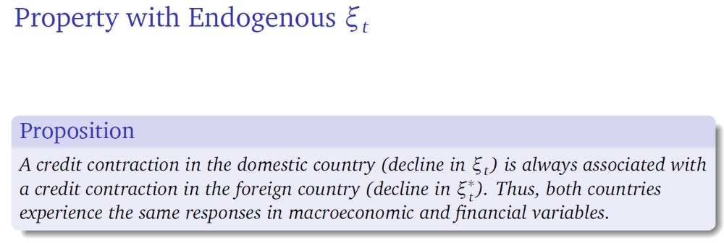

Result 1: Asymmetry: Credit contractions have larger macroeconomic and asset price effects than expansions
Result 2: Recessions Led by Credit Booms: The severity of crises increases with the duration of the credit expansion
Result 3: Employment and Asset Price Volatility: Credit shocks generate large fluctuations in employment and asset prices
Result 4: Heterogeneous Responses of Labor:Heterogeneous response of employment but similar responses of financial
variables and other real variables

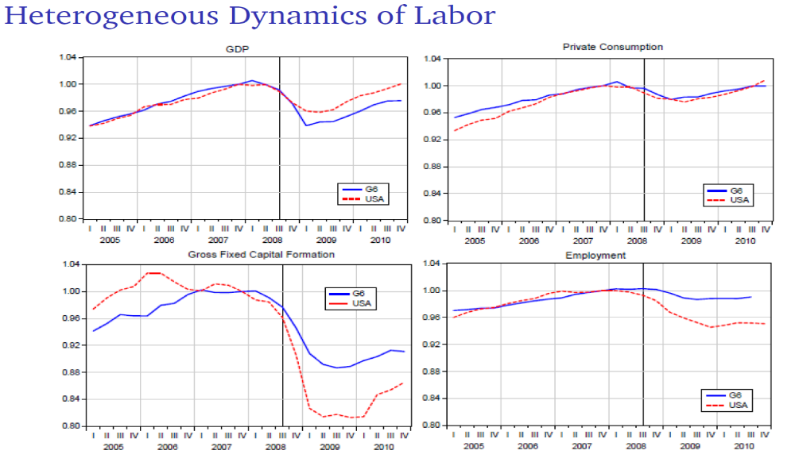
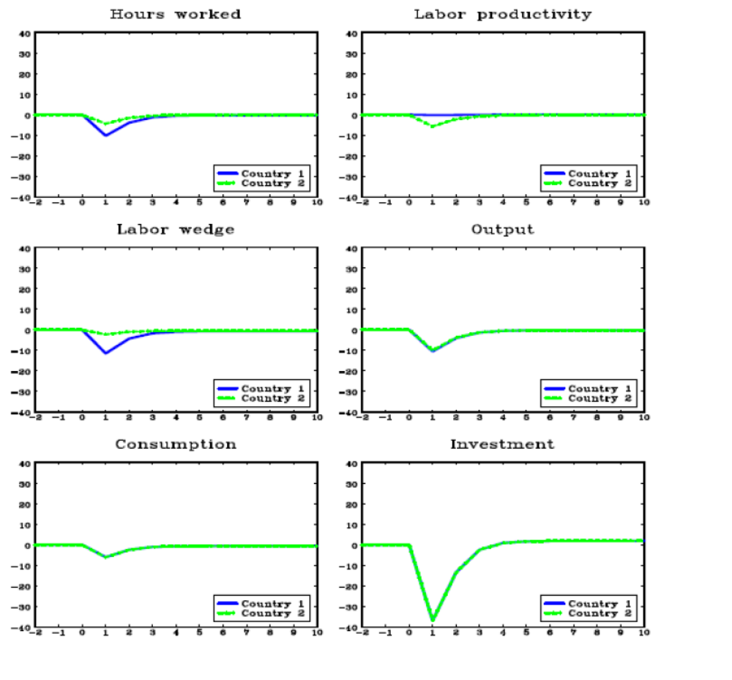
Conclusions: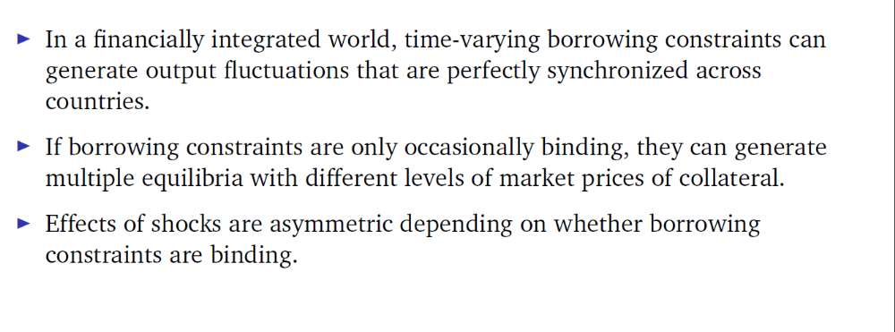
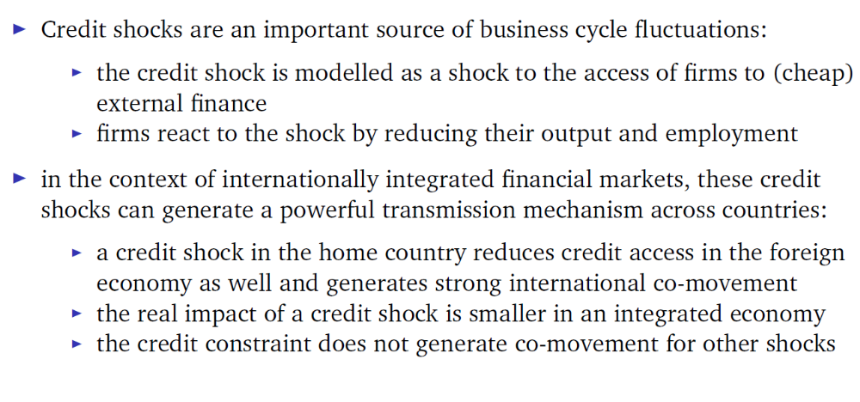
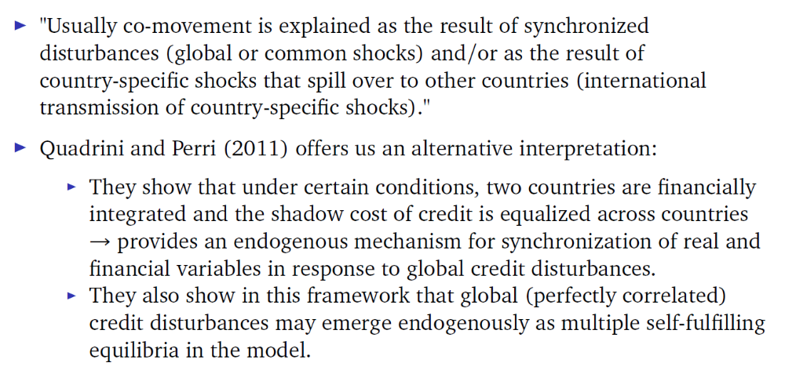
b) Devereux and Yetman: Leverage Constraints and the
International Transmission of Shocks

Slides courtesy of Luca Macedoni

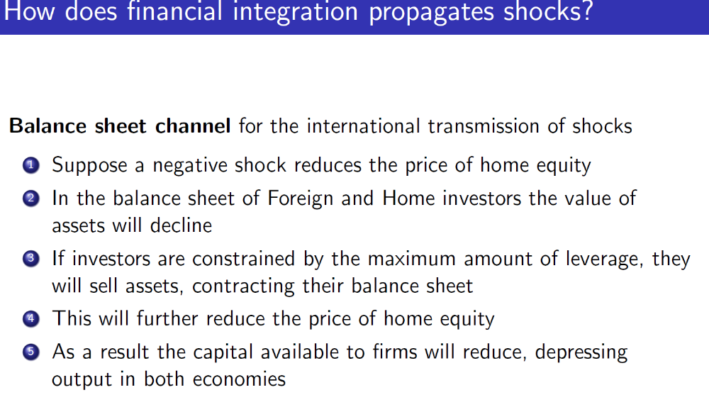
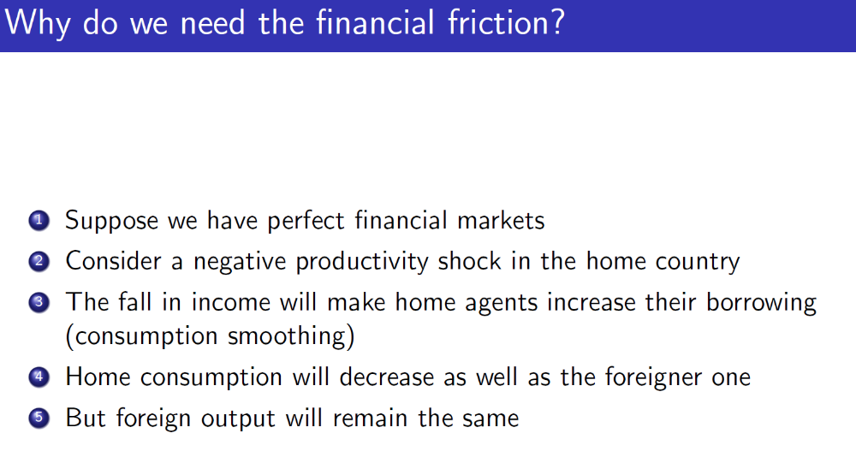
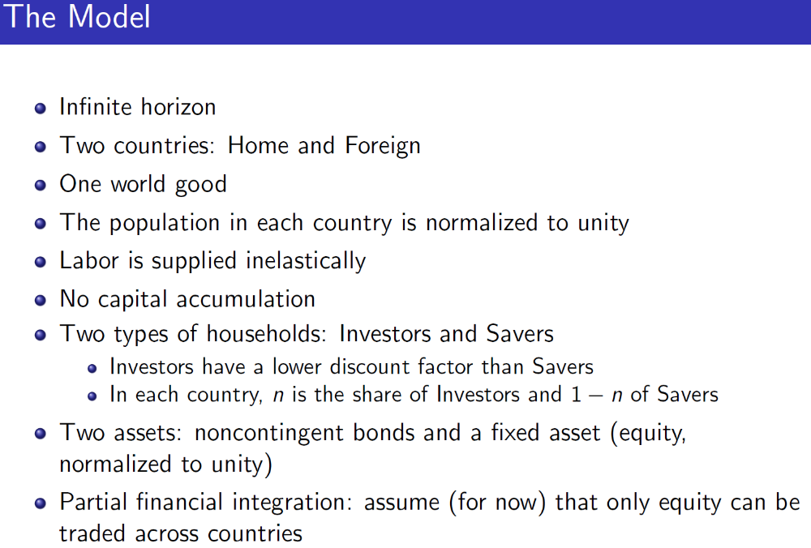
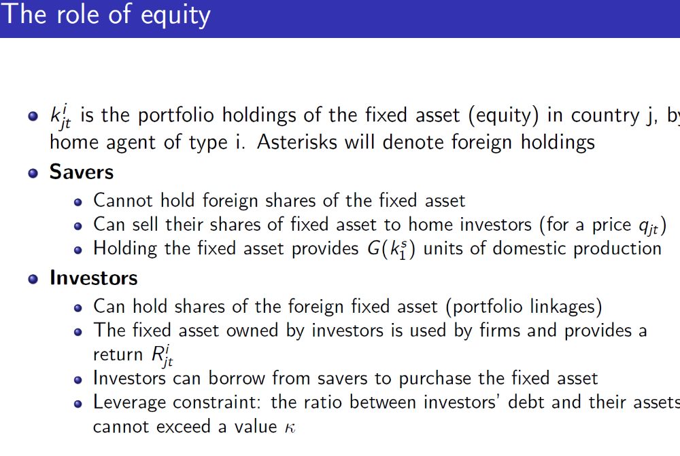
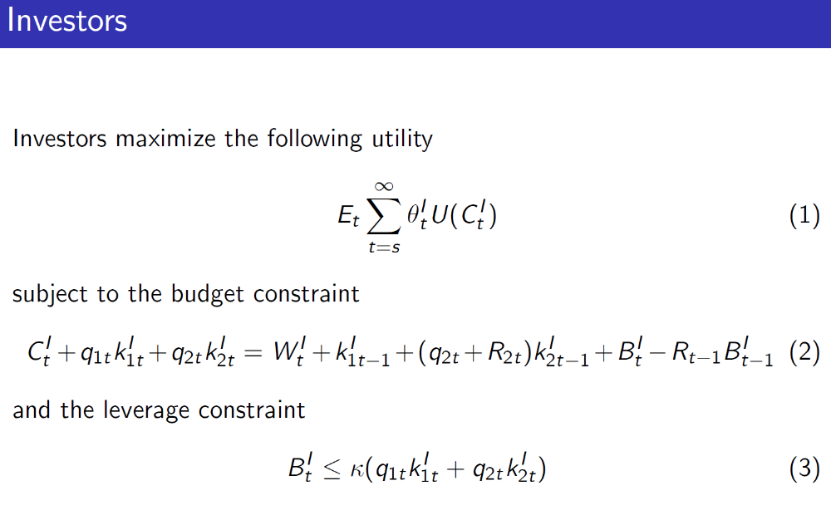

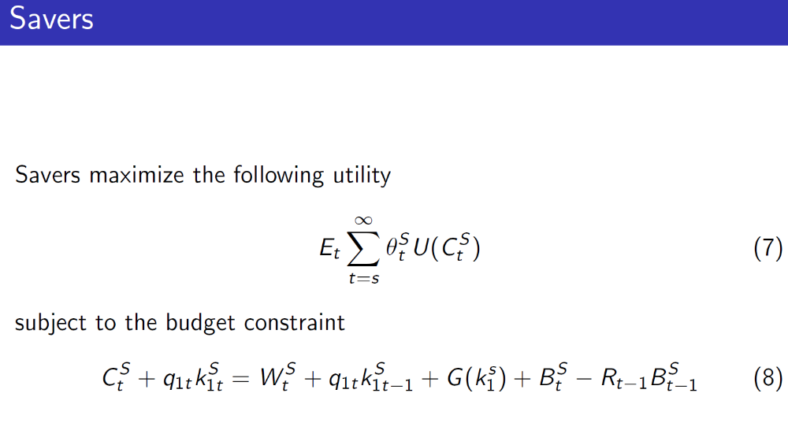
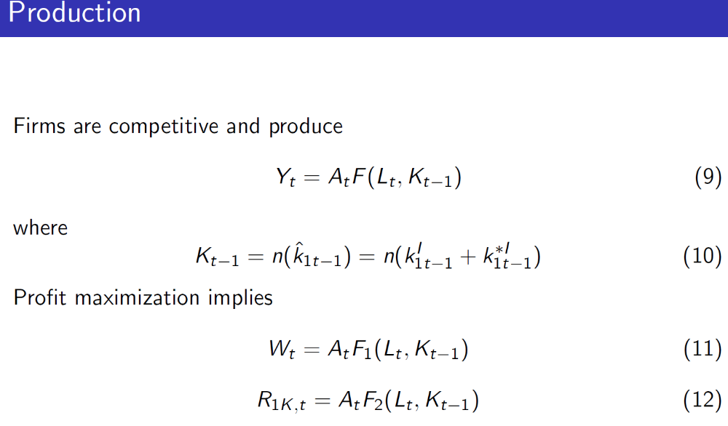
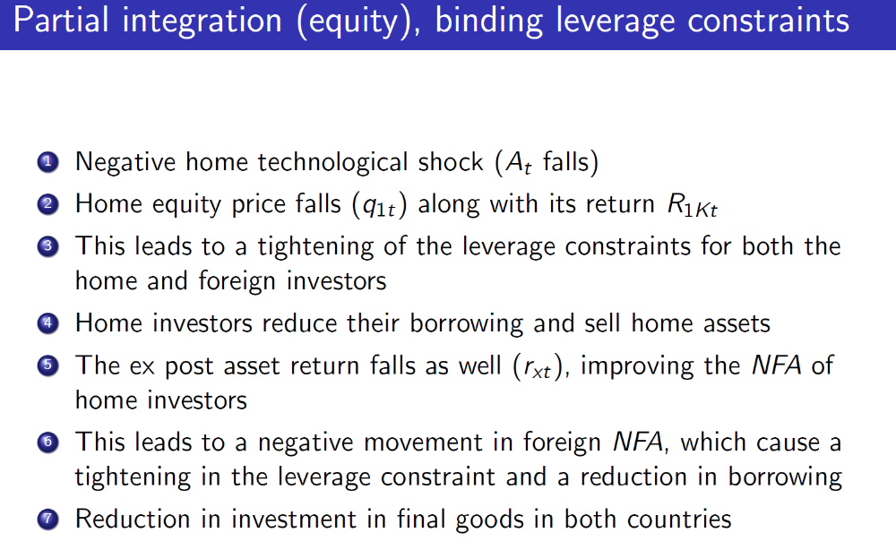

- There is a clear positive comovement across countries.

- Qualitatively, the transmission is similar to Figs 5 and 6, except now there is a single world debt market.

- Shock leads to a fall in the price of the home asset and, from arbitrage condition (8), the foreign asset price also falls.

- Given the hedged portfolio position of the home country, the fall in the return on the home asset leads to an increase in home NFA due to valuation effects.

- For the foreign country these valuation effects are negative, leading to tightening of foreign leverage constraint.

